Eyesalve
Volume 1, Issue 1 August 2014
Introduction and Basis for this Edition
The Message of God’s Character by Ryan Griffith
I believe that the message that God wants before His people today is the message of His character. The Good news is really who God is, and following that, knowing that God can be trusted. Trusting God to do what He has promised.
God spoke to Laodecia saying “…and anoint thine eyes with eyesalve, that thou mayest see (Rev 3:18 KJV).” We are in the period of the church where this testimony is for God’s people today. Deception of any kind will be pressed upon the people who love and fear God. Now more than ever we need the heavenly eyeslave to see; the Psalmist says “Open﻿^{b}﻿ thou mine eyes, that I may behold wondrous things out of thy law.” The law of God; the moral law of God; reveals the character of our gracious God and the broken law is the reason for the gospel of salvation full and free. The Broken law demanded rhe death of the offender, the righteous God demanded the freedom of His guilty children and so the gospel was born.
Many false gospels have gone out (Galatians 1:7). God requires His people to know the enemy’s tricks and strategies (2 Corinthians 2:11) and has offered Heavenly discernment to identify the truth from the error.
God is sending a message to His people to prepare them to meet their God to say to the world “… this is our God; we have waited for him, and he will save us: this is the LORD; we have waited for him, we will be glad and rejoice in his salvation (Isaiah 25:9).” These people are the redeemed of God there here the message of the kingdom and obey it. They understand the true Gospel of Jesus Christ. They Love God supremely and their neighbour as themselves. They are the fulfilment of the prayer of Jesus in John Chapter 17.

How did they get to that point?
It all started with Jesus and ended with Jesus. The rest is just a matter of keeping the faith. As we look closer at important truth in this letter I pray that your heart will burn as does mine each time I receive the truth about the character of our loving heavenly Father.

Introduction to Prophecy

God alone knows the future (Isaiah 46:9, 10) by the simple fact that He is God. God has given the more sure word of prophecy to guide His people into the light of all truth (2 Peter 1:18, 19) and He has given His word that before He does anything He will reveal it to His servants and the people who love and trust Him (Deuteronomy 29:29).

The prophets of God always looked forward to the fulfilment of God’s promise to restore His people to their rightful state, to grant them freedom from sin and total deliverance from the opposer of the truth (1 Peter 1:9-11).
Jesus Himself directed the people of God to the scriptures concerning the future. In Matthew chapter 24 the disciples of our Lord are seen asking three important questions: “when shall these things be? and what shall be the sign of thy coming, and of the end of the world? (Matthew 24:3)”
Jesus answers them all but it is the last question primarily that is the focus of prophecy.
What shall be the sign … Of the end of the world?
Our Saviour directs the His people to the prophet Daniel. "When you therefore shall see the abomination of desolation, spoken of by Daniel the prophet, stand in the holy place, (who reads, let him understand)!' (Matthew. 24: 15).
This prophecy had application at that time to the destruction of Jerusalem by the romans in A.D. 70. Luke says in a parallel passage to Matthew 24:15 “When ye shall see Jerusalem compassed with armies, then know that the desolation thereof is nigh” (Luke. 21:20). Here Jesus was warning to flee from the certain destruction at the hands of the abomination of desolation or Pagan Rome.
Jesus recognizes Daniel as the writer of the book that bears His name, an actual historical person and a prophet. In the book of Daniel are more prophecies that relate to the end of the world and the coming of Jesus to restore His kingdom, His kingly authority, His sanctuary and His people.
The book of Daniel must be studied carefully with the Revelation of John the Apostle (Daniel 12:9; Revelation 10:2, 8). They reveal events that are soon to happen in our world and hold the keys to what God’s people today should be doing in relation to God’s plan for them.

Health

Pure air, sunlight, abstemiousness, rest, exercise, proper diet, the use of water, trust in divine power--these are the true remedies. … {MH 127.2}

Too little attention is generally given to the preservation of health. It is far better to prevent disease than to know how to treat it when contracted. It is the duty of every person, for his own sake, and for the sake of humanity, to inform himself in regard to the laws of life and conscientiously to obey them. All need to become acquainted with that most wonderful of all organisms, the human body. They should understand the functions of the various organs and the dependence of one upon another for the healthy action of all. They should study the influence of the mind upon the body, and of the body upon the mind, and the laws by which they are governed. {MH 128.1}

How to Study the Bible?
Ellen. G. White

Search the scriptures; for in them ye think ye have eternal life: and they are they which testify of me. John 5:39. {HP 138.1}
It is not enough to study the Bible as other books are studied. In order for it to be understood savingly, the Holy Spirit must move on the heart of the searcher. The same Spirit that inspired the Word must inspire the reader of the Word. Then will be heard the voice of heaven. . . . {HP 138.2}
The way id narrow but the reward is eternal.
The mere reading of the Word will not accomplish the result designed of heaven; it must be studied and cherished in the heart. The knowledge of God is not gained without mental effort. We should diligently study the Bible, asking God for the aid of the Holy Spirit, that we may understand His Word. We should take one verse and concentrate the mind on the task of ascertaining the thought which God has put in that verse for us. We should dwell on the thought till it becomes our own, and we know "what saith the Lord." {HP 138.3}

Theology, Is it worth it?
For many there seems to be a sharp disconnect between theological studies and practical Christianity. Why all the big words and themes if the gospel is so simple?
God has moved upon many people and many different minds and persons studying theology are not exempt. If the heart is right God will lead the searcher into all truth it is not safe to dismiss truth on the basis of opinion of self-motivated ideas, they can be detrimental to the soul.
It is the heart not necessarily the method that God

“If the heart is right God will lead the searcher into all truth it is not safe to dismiss truth on the basis of opinion of self-motivated ideas.”
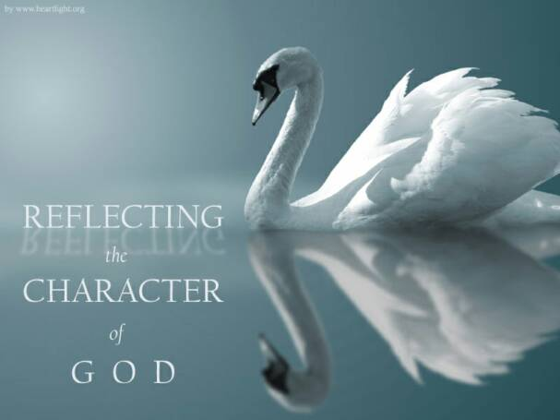

continued on page 2
continued on page 3

Inside This Issue
1 | The Reason For This Publication
2 | Bible Study by E. G. White
3 | Introduction to Bible Prophecy
4 | Health
5 | Theology, Is It worth it?
continued from page 1
continued from page 1

Contact Information
Feel free to contact us with your thoughts, questions or comments. We love to hear from you and know how the message is impacting you in your walk with the Lord.
godscharacter@gmail.com
www.godscharacter.weebly.com

Also check out the contact information on the website.
SPECIAL NOTE FROM THE EDITOR
The scriptures make it plain that eyeslave is ointment provided by the Divine Physician to give discernment of the truth. The word 2854 κολλούριον [kollourion /kol·loo·ree·on/] n n. From a presumed derivative of kollura (a cake—; GK 3141; AV translates as “eyesalve” once. 1 a preparation composed of various materials and used as a remedy for tender eyelids.
The application is made in Revelation 3:18 to the Laodecian in the end times to allow for various things but especially to discern truth from error. The purpose of this publication is therefore to promote the important truth for this time, that is, the truth of the Great Controversy over the character and government of God. All truth placed in its proper setting of the Great Controversy form a harmonious whole.
Bro. Ryan Griffith.
Theology is it worth it?
For many there seems to be a sharp disconnect between theological studies and practical Christianity. Why all the big words and themes if the gospel is so simple?
God has moved upon many people and many different minds and persons studying theology are not exempt. If the heart is right God will lead the searcher into all truth it is not safe to dismiss truth on the basis of opinion of self-motivated ideas, they can be detrimental to the soul.
It is the heart not necessarily the method that God is most interested in but through the both talents bringing employed God can do even more.
let’s take a fresh look at the place of Theology in the daily Christian experience together.

